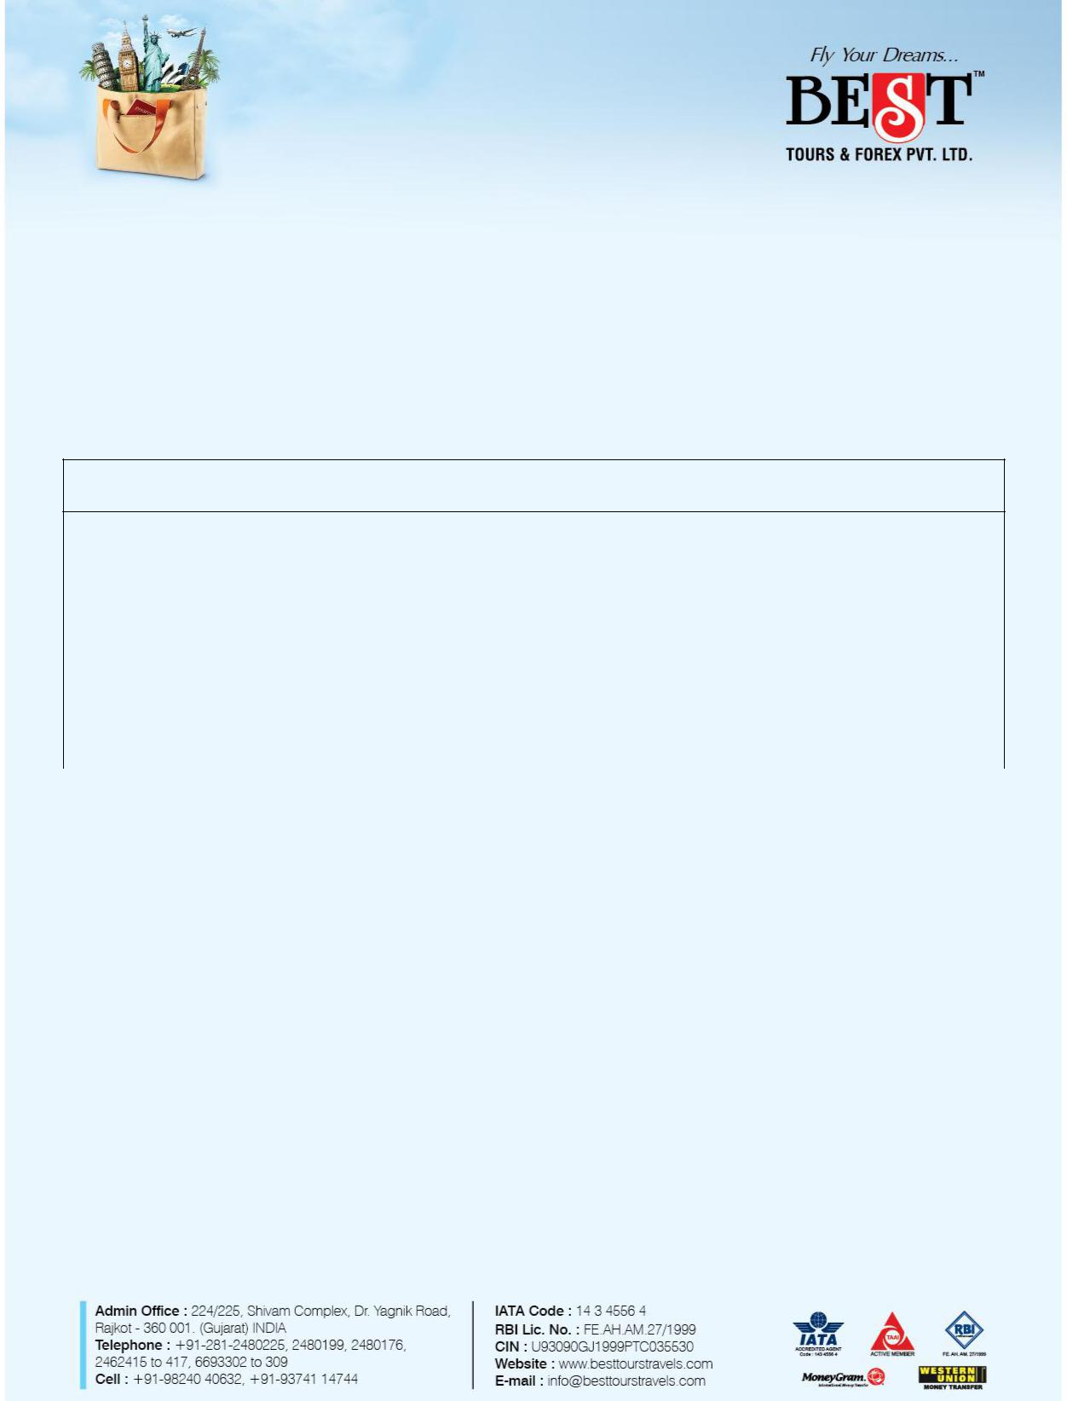

**Nainital - 09 days**

**Departure Dates: 11th and 18th May 2017**

|  |  |  |  |  |  |  |
| --- | --- | --- | --- | --- | --- | --- |
| **Airline Details:** | | **Meals:** | | **Transportation:** | |  |
| ➢ Economy class **Air Ex-Ahmedabad** | | ➢ | **08 Breakfasts** | ➢ | A/C Vehicle on sharing basis |  |
| ➢ | All Airlines Taxes (Current Rated) | ➢ | (As per Laws, AC will not be operated in |  |
|  | ➢ | **08 Dinners** |  |  |
| ➢ | By AIR – Ahmedabad-Delhi-Ahmedabad |  | Hills) |  |
|  |  |  |  |  |  |  |

**Hotels(3 Star)**

**Tour Plan:**

|  |  |  |  |  |  |  |  |
| --- | --- | --- | --- | --- | --- | --- | --- |
| **Nainital : 3 Nights** | | |  | **Jim Corbett : 2 Nights** | |  |  |
|  |  |  |  |  |  |  |  |
| **Kasoni : 2 Nights** | | |  | **Delhi : 01 Night** | |  |  |
|  |  |  |  |  |  |  |  |
|  |  |  |  | |  |  |  |
|  |  | **Currency Payment** | **Per Adult** | | **Extra Adult** | **Extra Child** |  |
|  | **Tour cost** |  | **(Above 12 years)** | | (5-12 years) | **(Below 5 years)** |  |
|  |  |  |  |  |  |  |  |
|  |  | **INR** | **39,000** |  | **28,000** | **12,000** |  |
|  |  |  |  |  |  |  |  |

**\* * c h i l d 2 - 1 1 y e a r s**

**Service Tax Extra** **\* * * I n f a n t b e l o w 2 4 m o n t h s**

**T o u r c o s t d o e s n o t in c lud e :**

* `Tips, Laundry, Hard drink, Soft drink, Porterage, Mineral water, Lunch ,Personal transportation which are not included in itinerary.
* Mediclaim.
* Airline / Room / Cabin Upgrades and Complimentary are not included unless specifically mentioned.

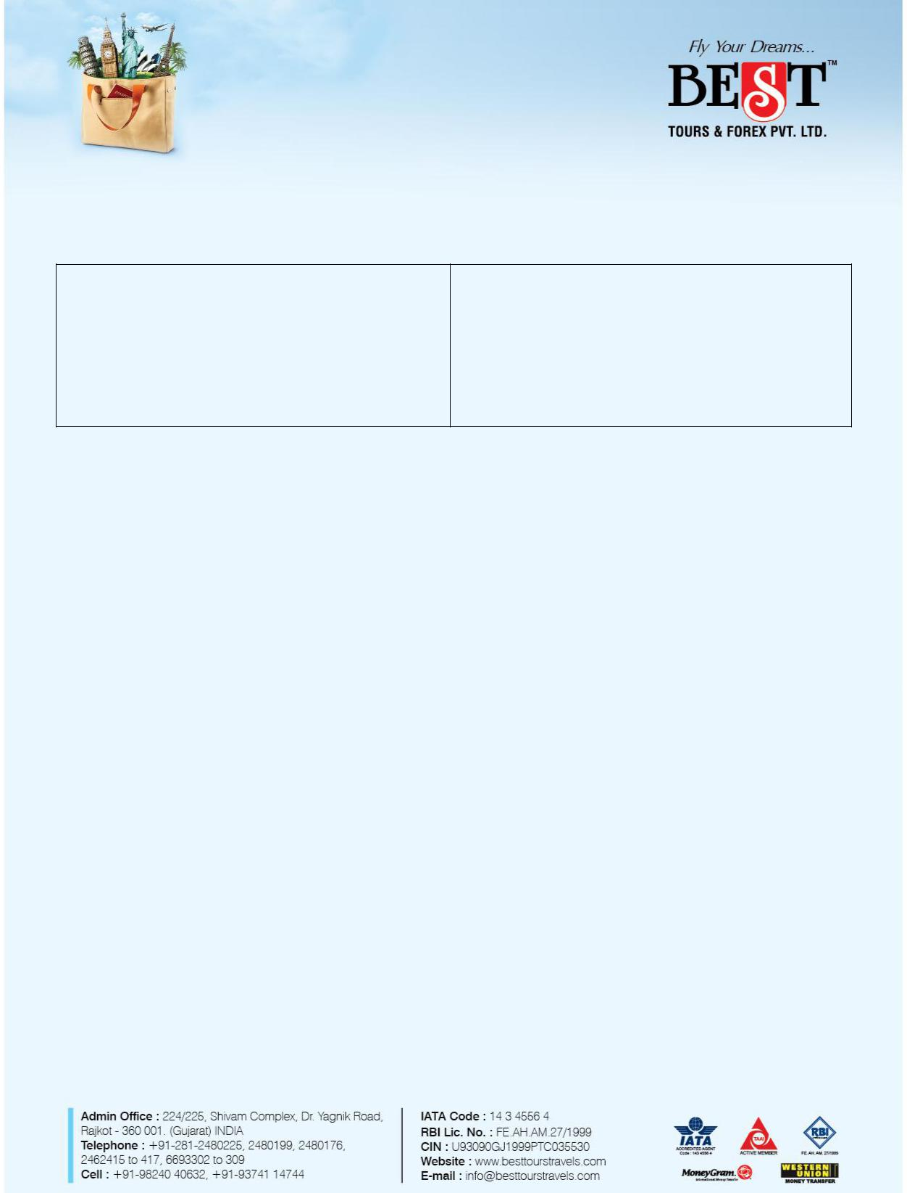

**B o o k i n g F o r m al i ti e s :**

* Advance payment of INR 50% of package cost against booking.
* Remaining Payment has to be made 30 days before departure.
* Copy of Valid photo ID proof.

**Flight Details**

|  |  |  |  |
| --- | --- | --- | --- |
| 6E 158 | 11-May AMD DEL | 06:20 | 07:50 |
| 6E 157 | 19-May DEL AMD | 20:40 | 22:10 |

|  |  |  |
| --- | --- | --- |
| 6E 158 18-May AMD DEL | 06:20 | 07:50 |
| 6E 157 26-May DEL AMD | 20:40 | 22:10 |

**Contact – Siddharth Ahya - 9898236194**